Hub-in-a-Box Tips

Seattle Emergency Communications Hubs

The following information is intended to help guide new Community Hubs through the process of purchasing and installing a Hub-in-a-Box as part of the 2020 Hub-in-a-Box Program. If you have questions, please contact:
- Seattle Emergency Hubs: Cindi Barker, CindiLBarker@gmail.com or 206-933-6968
- Department of Neighborhoods: Juan Martinez, juan.martinez@seattle.gov or 206-733-9259

Before you get started, some things to know.

Eligibility Criteria
- Maintain a primary contact (and backup, if possible) with Seattle Office of Emergency Management.
- Agree to appear on the Emergency NeighborLink Map so other community members are aware.
- Have at least 3 to 5 people as a core workgroup who agree to exchange information and meet at a designated location related to the hub.
- Designate a meeting location that must be outside of a City-owned building.
- Attend a Hub Orientation offered by the Seattle Office of Emergency Management or the Hub Captains Network.
- Display a public placard, signage or other designation of your Community Emergency Hub.

Basic steps and considerations for all Hub-in-a-Box Applicants. Make sure to read all the way to the end before you start!

If you have established yourself as a hub that meets the minimum criteria described below, you can apply for up to $1,800 for a Hub-in-a-Box.

STEP 1. Pick your Hub box location, coordinate the box location with the property owner and obtain permission.
- For private property, be sure everyone agrees, especially if property owner is not a tenant of the building. Document your agreement with the property owner.
- Ensure that the location will not interfere with normal business for the property owner and ask how the box will be “known” to employees so that it is not accidently removed.
- Boxes should be secured in place, either to concrete pad or to a wall. It should be outside a building, so you can access it if the building is damaged in a disaster.
- If your location is going to be on Parks Property, you will need to contact Seattle Parks Department Emergency Manager (Jon Jainga, jon.jainga@seattle.gov, 206-684-8685). They will work with you for a series of special steps (see section 5 for more details)

STEP 2. Pick your box
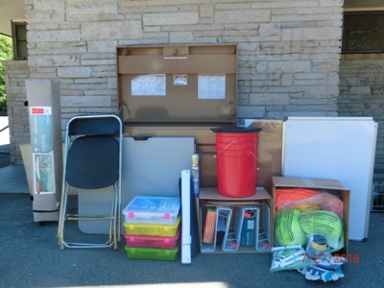
- Most Hubs pick a 4-foot or 6-foot wide Knaack job box, depending on the items you want to store. The 4-foot box will hold a 6-foot folding table and two chairs, and a shelter tent that is shorter than 48 inches. It will be a tight fit with all the other gear (see photos to the right). One other model has a top shelf for storage; some choices are shown below from the Knaack brand, which is what most hubs have ordered to date. (NOTE: The Seattle Parks Department requires that boxes in parks be no larger than the 4-foot size).
Choosing and filling your Hub-in-a-Box
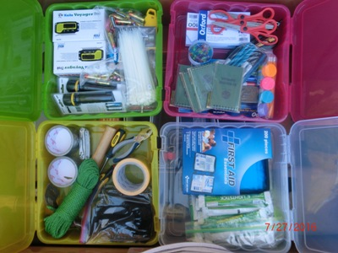
- Pick your locking mechanism. Do you want to issue keys or have a combination arrangement? Will your group have several boxes and if so, do you want them to all have the same key or combination? You will need to have plans to install and lock your boxes ready for the date of delivery, so your box is immediately secured.

STEP 3. Identify how much equipment you want to store in your Hub-in-a-Box.
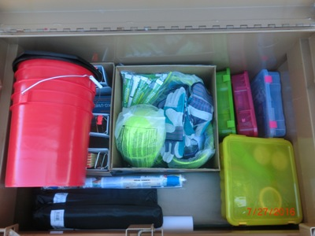
- Will it just be communications type equipment? Will you want to store shelter tents, tables and chairs? It will make a difference on what size box you select. You will have an Excel spreadsheet with your application to make selection of your box and equipment easy.
- The City application has a template you will use to pick which supplies and materials you want. Your total purchase, including the box, common supply kit, any other special items you would like, and estimated taxes cannot exceed $1,800.
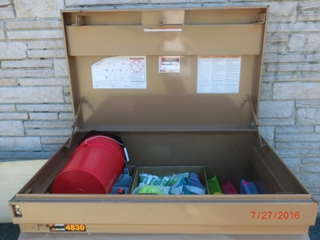
STEP 4. Delivery and Installation
- Coordinate installation time and permission to do any drilling or concrete work for bolting with the property owner. Installation can be as simple as chaining to a fence post or drilling 4 footing holes and bolting down to concrete when located on private property. The City will deliver directly to the address you have selected and will work with the box vendor to confirm delivery and receipt.

STEP 5. Only If your Hub-in-a-Box will be located on Parks property, follow these steps:
  - Review this list or contact Jon Jainga, jon.jainga@seattle.gov, 206-684-8685 or Cindi Barker at CindiLBarker@gmail.com in advance of your application to see if your potential Parks site is on the approved list. If it is not, we can help with understanding why not and offer other options.
  - Meet with Parks Emergency Manager and the District Crew Chief, who will review the proposed location and make sure there are no underground reasons why they should not place a pad there.
  - The Parks Emergency Manager will prepare a cost estimate and schedule estimate. The costs incurred for installation will be billed to you or against your grant, so make sure and include those in your estimates! If a Hub is doing this without a City grant, Parks will bill it to the person who is coordinating the box installation.
  - Once location, installation costs and schedule are approved, the Hub purchases the job box and has it delivered to the City Shops at Westbridge.
  - The Parks Paint Shop will remove the decals on the box.
  - The Cement and Fence Shop will place the pad and then install the box.
  - The Hub pays for the installation, locks, and chains for the box.
  - A Memorandum of Agreement is prepared and signed between Parks and the Community Hub (See Sample MOA on the next page).

STEP 6. Celebrate your successful installation!

SAMPLE MOA for Hub-in-a-Box on Parks property
